LAB-10

Q1)

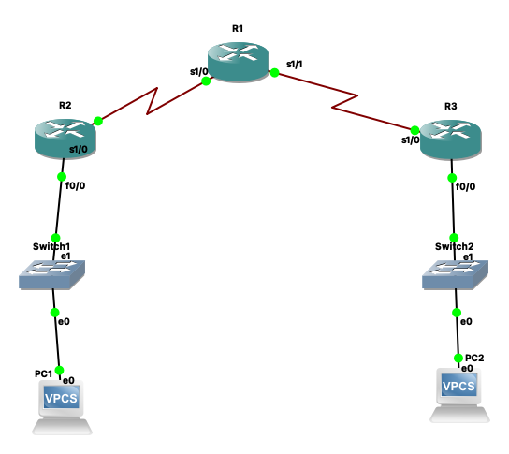

R1 configuration

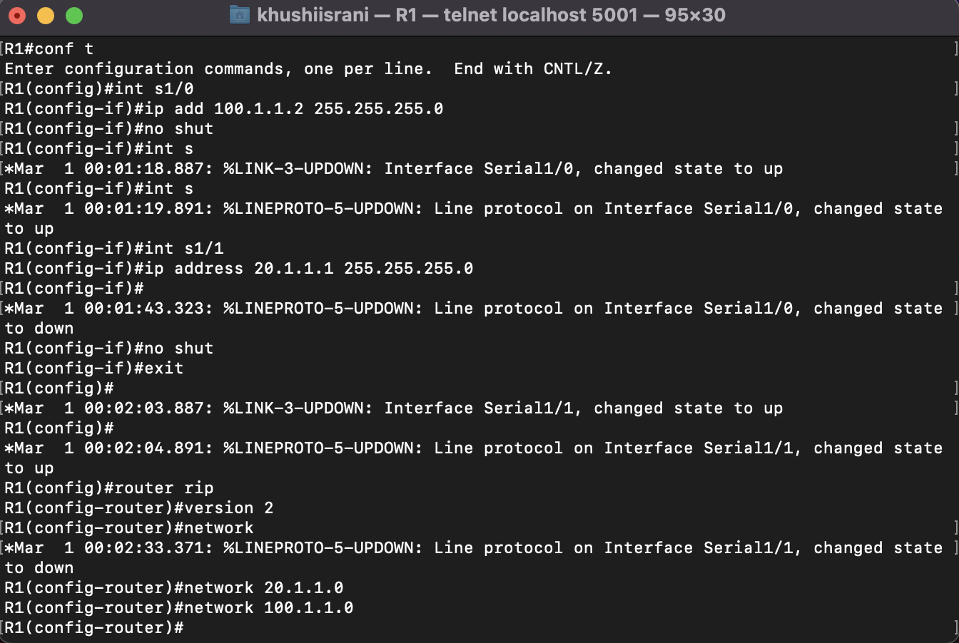

R2 configuration

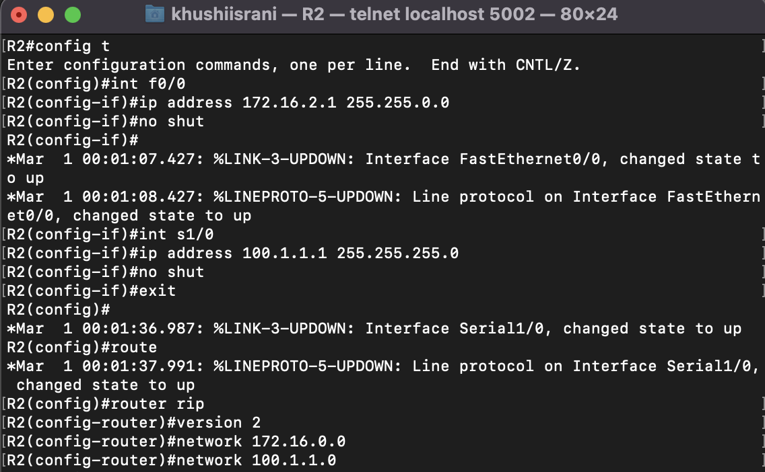

R3 configuration

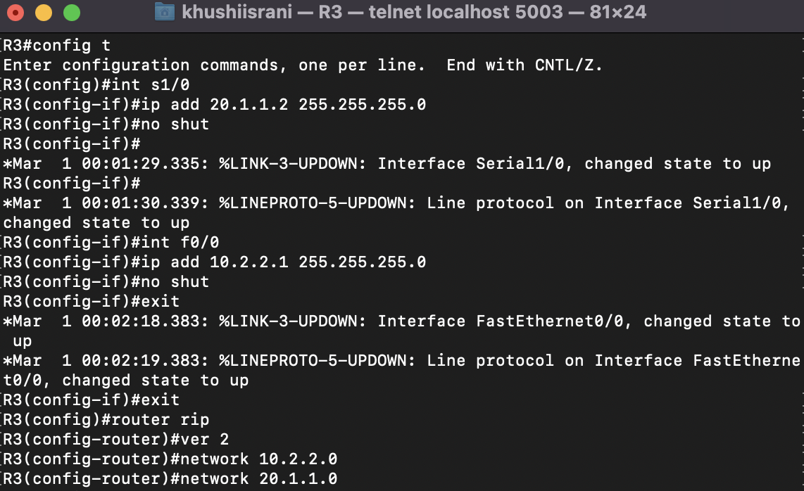

PC1 configuration

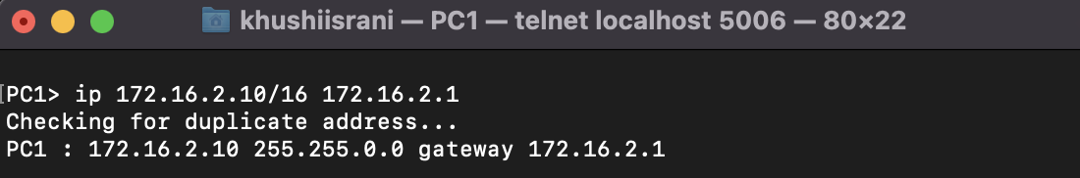

PC2 configuration

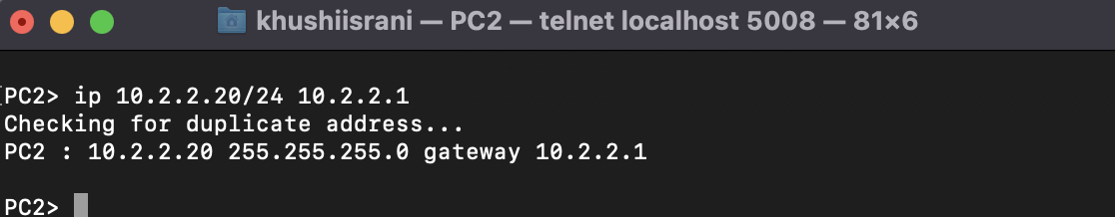

Show ip route for R1

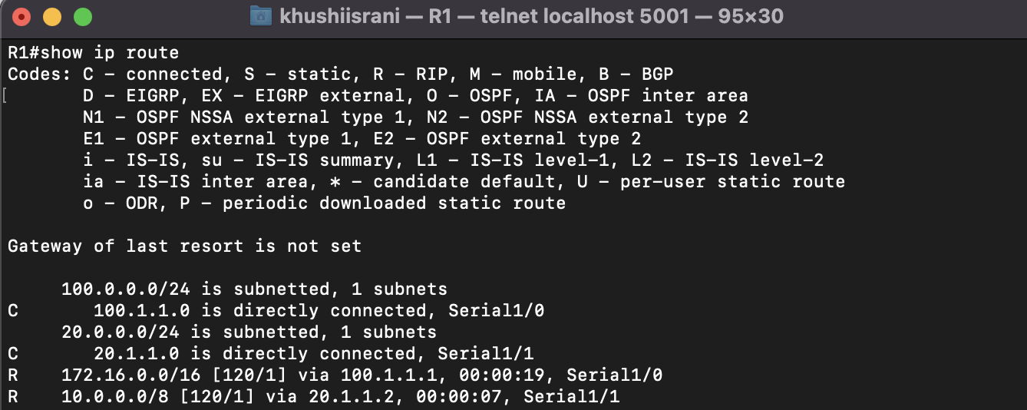

Show ip route for R2

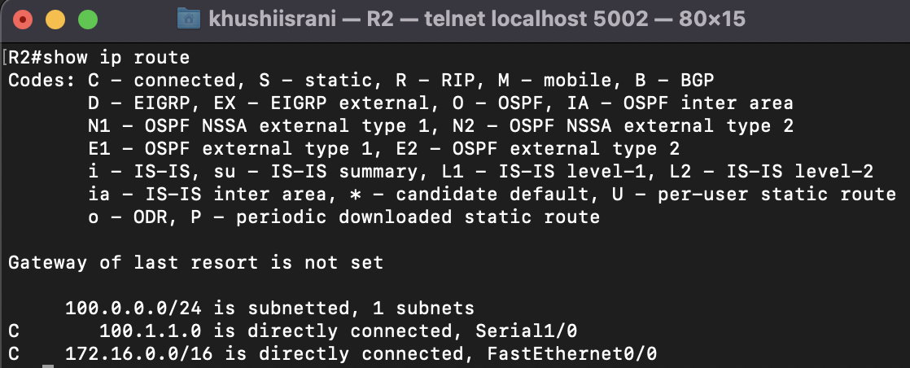

Show ip route for R3

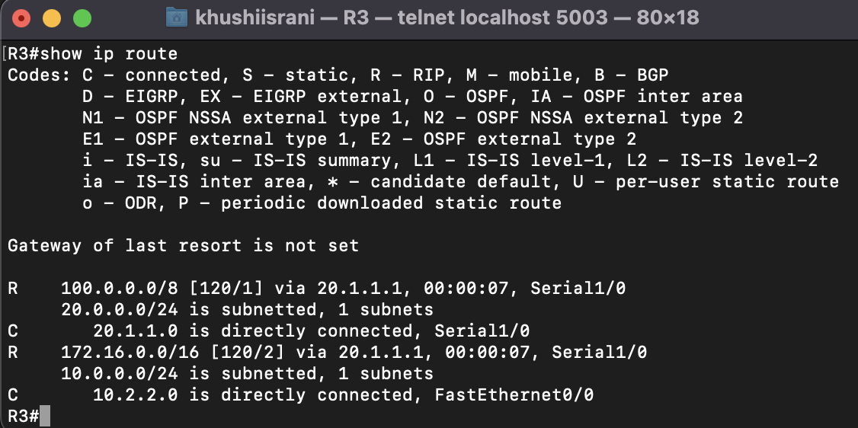

Show ip protocol for R1

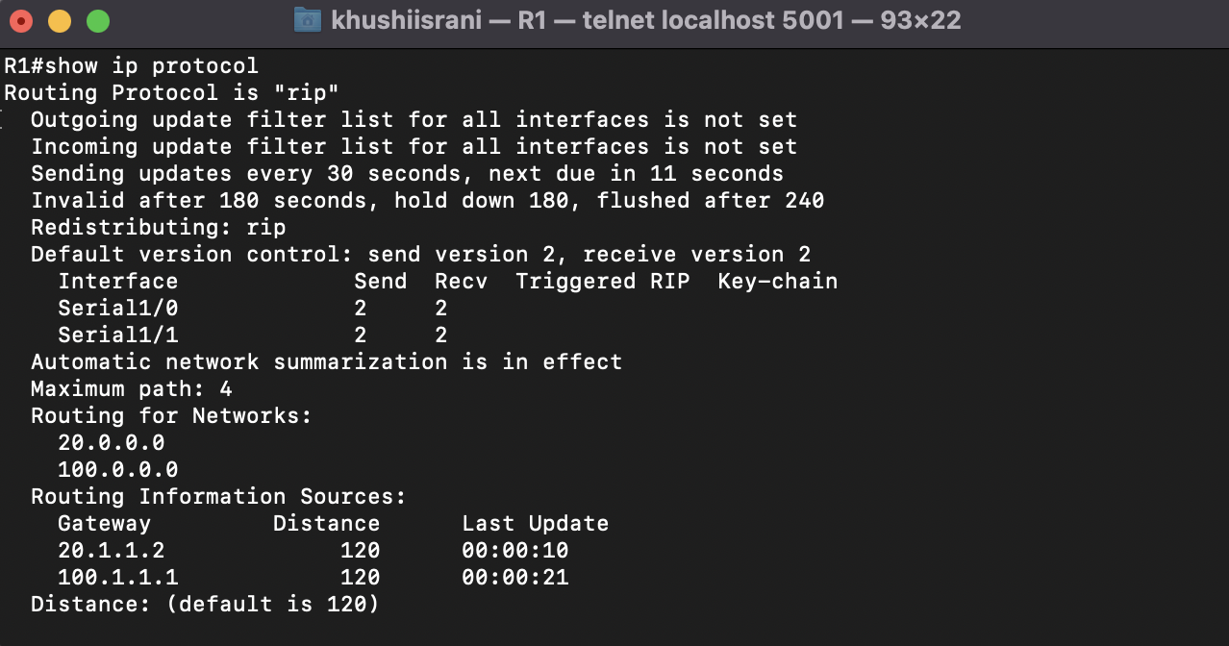

Show ip rip protocol for R1

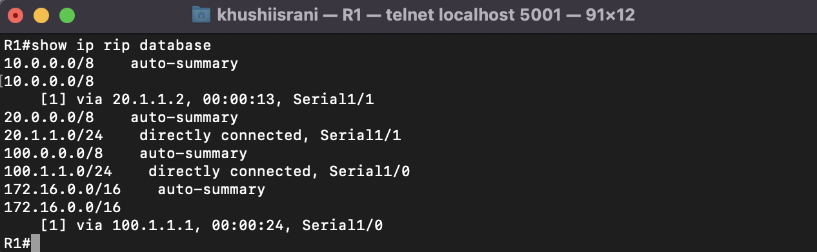

Q2)

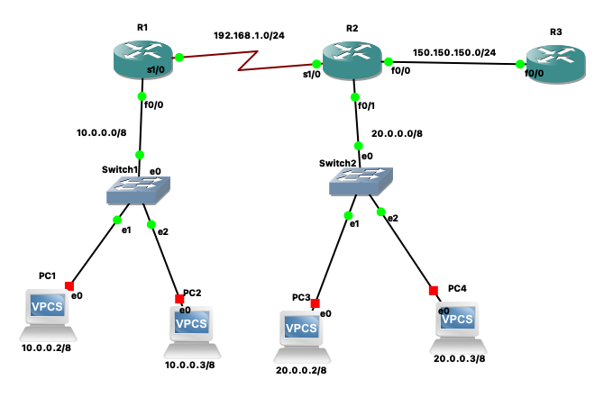

R1 configuration

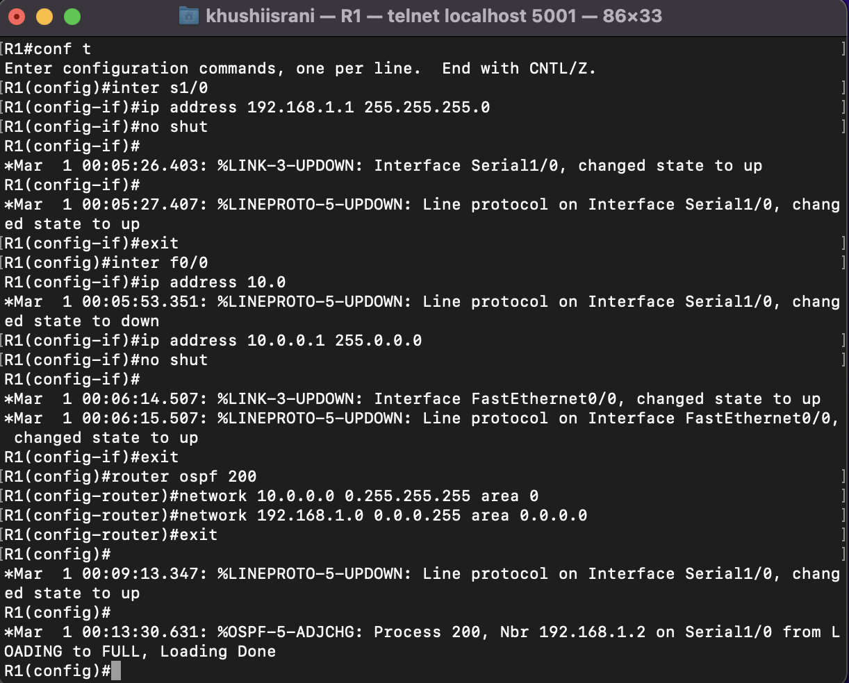

R2 configuration

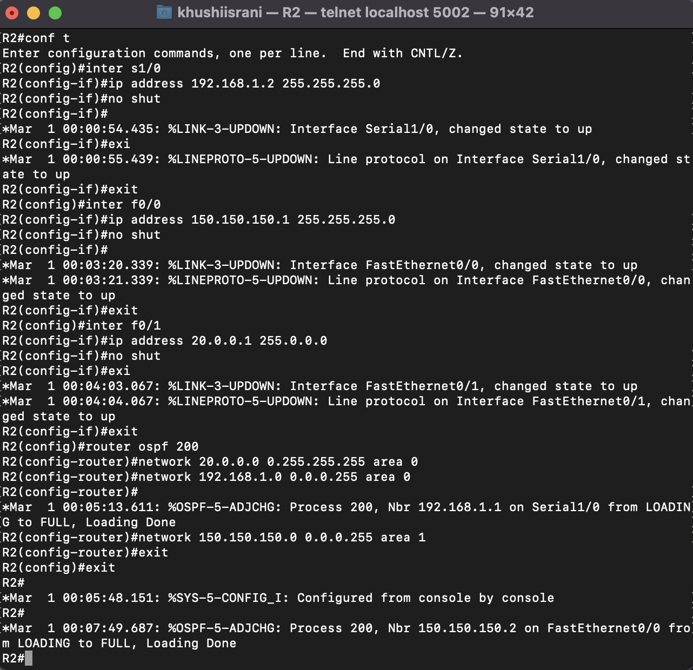

R3 configuration

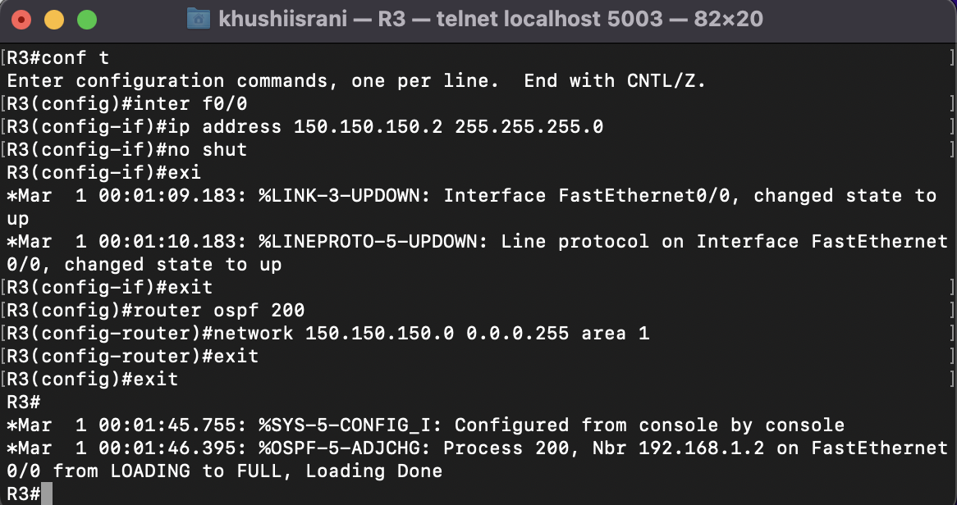

OSPF Verification for R1

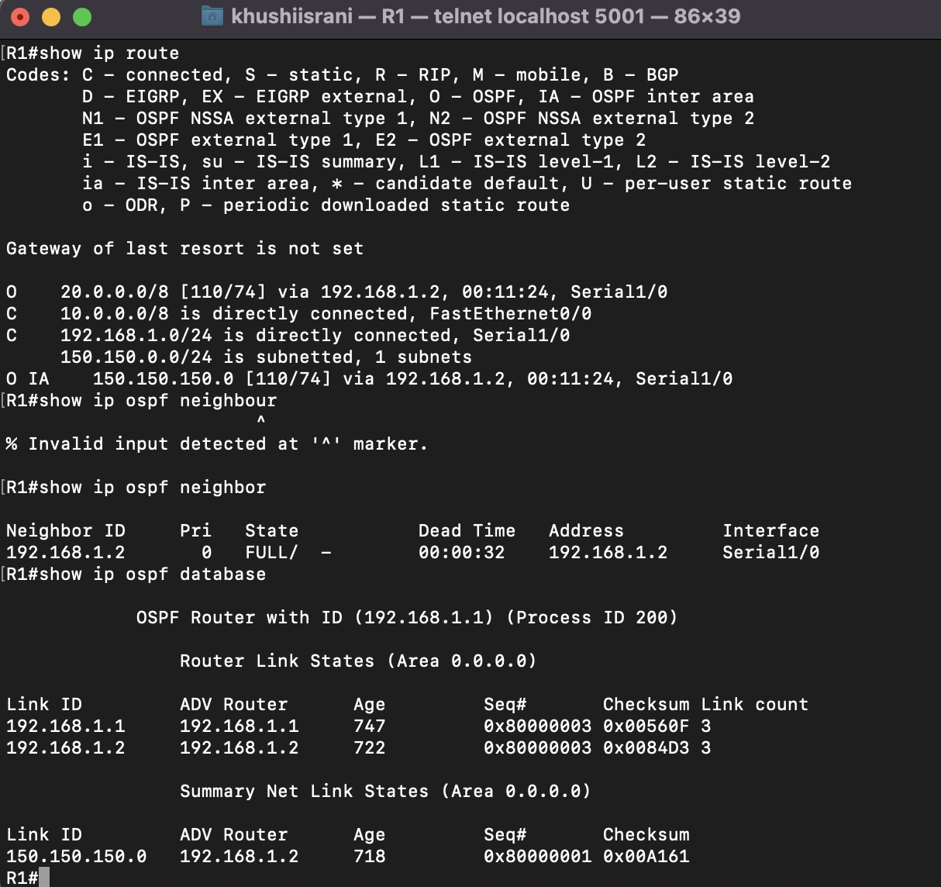

OSPF Verification for R2

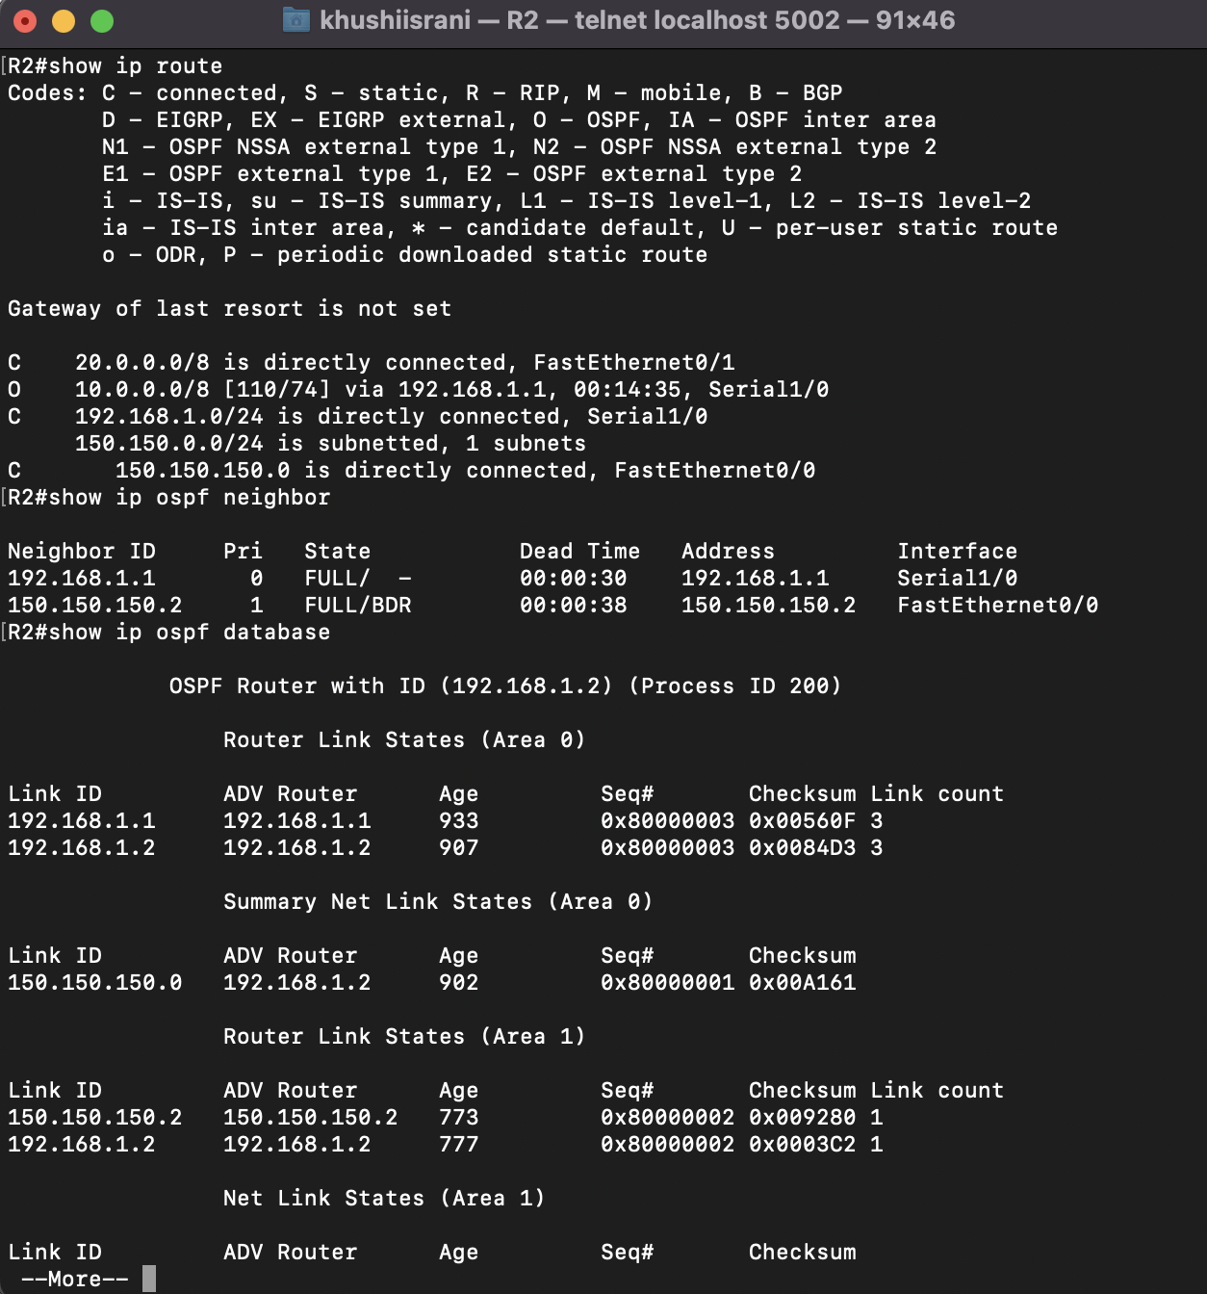

OSPF Verification for R3

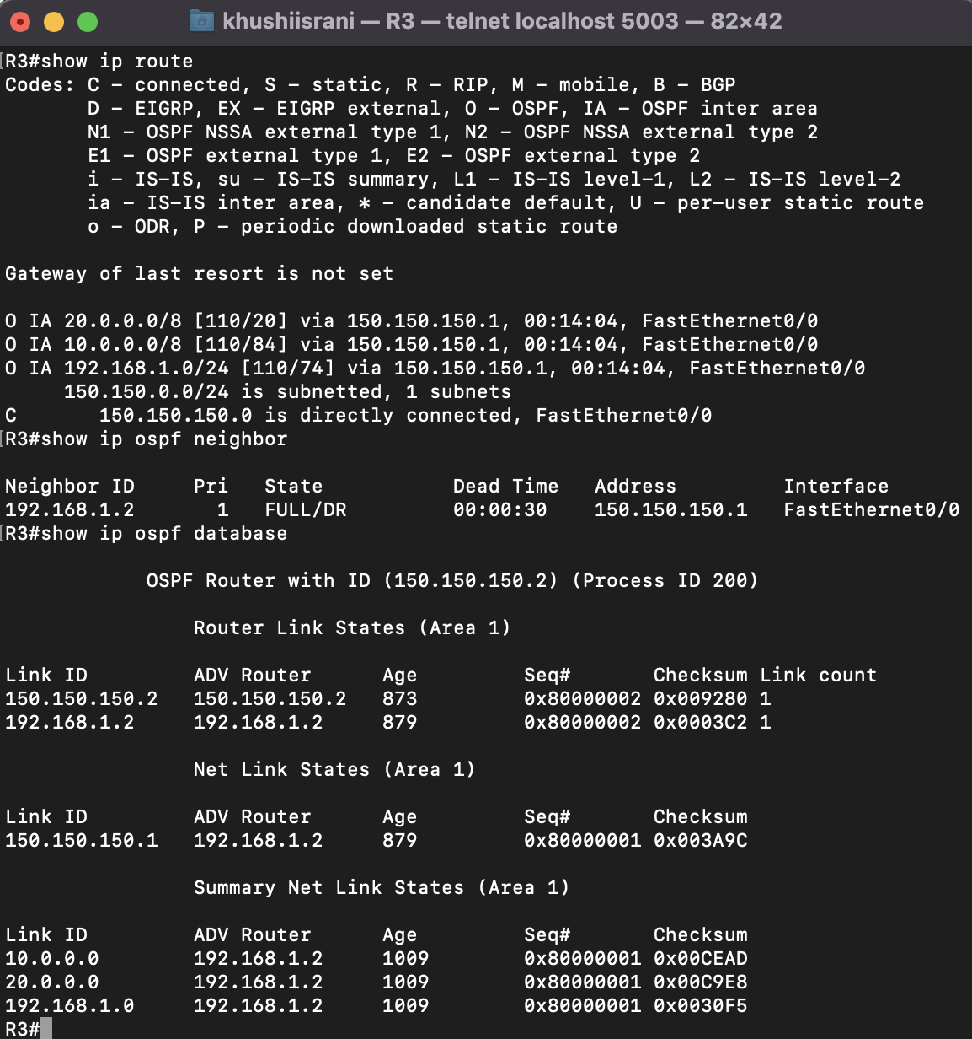

PC configurations: -

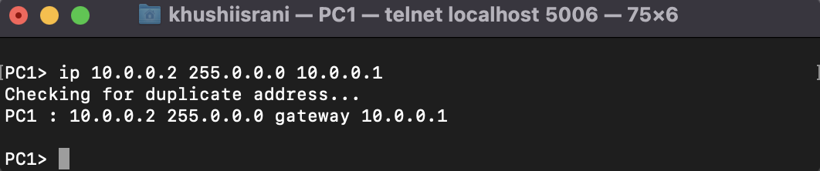

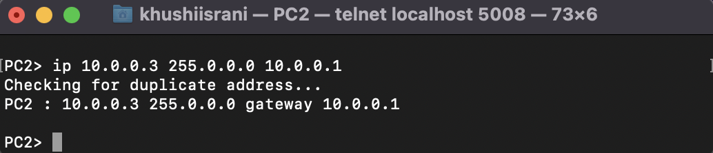

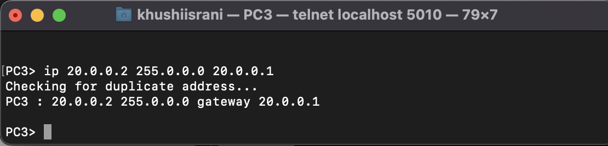

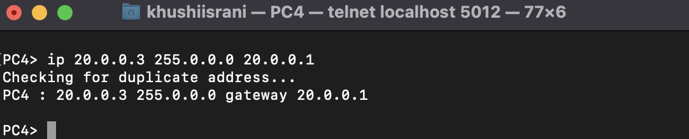

Pinging from PC1 to PC2, PC3 and PC4

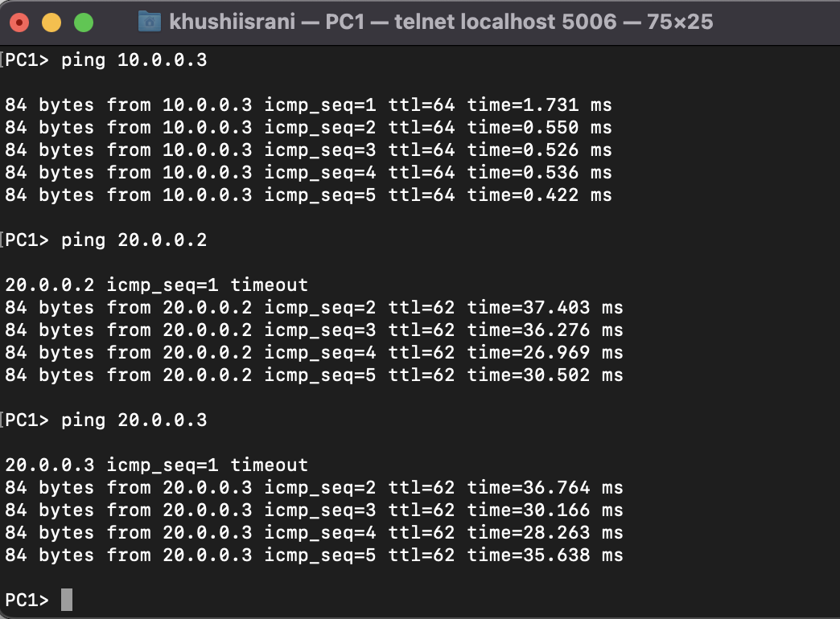

II. Configure the below network topology using RIP and OSPF as shown in Figure and check the

connectivity by pinging from PC1 to PC2, PC3, PC4.

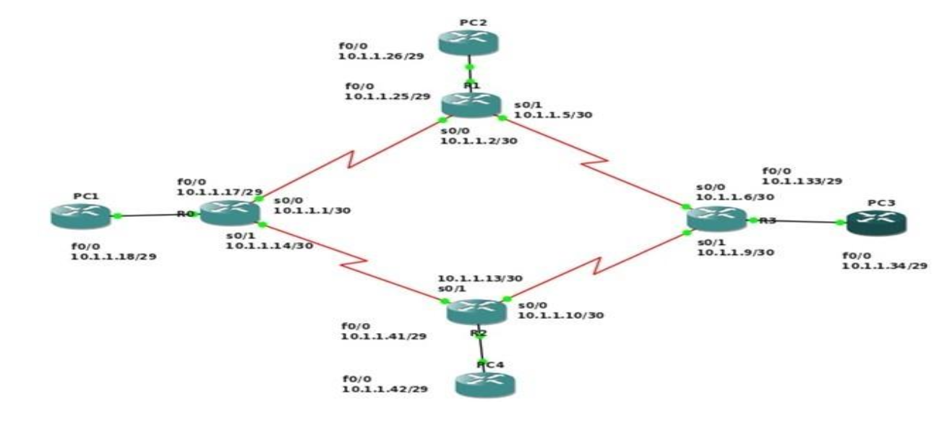

R1#conf t

Enter configuration commands, one per line. End with CNTL/Z.

R1(config)#inter s1/0

R1(config-if)#ip address 10.1.1.1 255.255.255.252

R1(config-if)#no shut

R1(config-if)#exit

\*Mar 1 00:00:42.107: %LINK-3-UPDOWN: Interface Serial1/0, changed state to up

R1(config-if)#exit

\*Mar 1 00:00:43.111: %LINEPROTO-5-UPDOWN: Line protocol on Interface Serial1/0, changed state to up

R1(config-if)#exit

R1(config)#inter s1/1

R1(config-if)#ip address 10.1.1.14 255.255.255.252

R1(config-if)#

\*Mar 1 00:01:03.503: %LINEPROTO-5-UPDOWN: Line protocol on Interface Serial1/0, changed state to down

R1(config-if)#no shut

R1(config-if)#exi

\*Mar 1 00:01:15.867: %LINK-3-UPDOWN: Interface Serial1/1, changed state to upt

R1(config-if)#exit

\*Mar 1 00:01:16.871: %LINEPROTO-5-UPDOWN: Line protocol on Interface Serial1/1, changed state to up

R1(config-if)#exit

R1(config)#inter f0/0

R1(config-if)#ip address 10.1.1.17 255.255.255.248

R1(config-if)#no shut

R1(config-if)#exit

\*Mar 1 00:01:43.207: %LINK-3-UPDOWN: Interface FastEthernet0/0, changed state to up

R1(config-if)#exit

\*Mar 1 00:01:43.527: %LINEPROTO-5-UPDOWN: Line protocol on Interface Serial1/1, changed state to down

\*Mar 1 00:01:44.207: %LINEPROTO-5-UPDOWN: Line protocol on Interface FastEthernet0/0, changed state to up

R1(config-if)#exit

R1(config)#router rip

R1(config-router)#version 2

R1(config-router)#network 10.1.1.16

R1(config-router)#exit

R1(config)#router rip

R1(config-router)#exit

R1(config)#router ospf 201

R1(config-router)#network 10.1.1.0 0.0.0.3 area 0

R1(config-router)#network 10.1.1.12 0.0.0.3 area 0

R1(config-router)#exit

R1(config)#exit

R2#conf t

Enter configuration commands, one per line. End with CNTL/Z.

R2(config)#inter s1/0

R2(config-if)#ip address 10.1.1.2 255.255.255.252

R2(config-if)#no shut

R2(config-if)#

\*Mar 1 00:00:38.115: %LINK-3-UPDOWN: Interface Serial1/0, changed state to up

R2(config-if)#

\*Mar 1 00:00:39.119: %LINEPROTO-5-UPDOWN: Line protocol on Interface Serial1/0, changed state to up

R2(config-if)#exit

R2(config)#inter s1/1

R2(config-if)#ip address 10.1.1.5 255.255.255.252

R2(config-if)#no shut

R2(config-if)#

\*Mar 1 00:01:18.279: %LINK-3-UPDOWN: Interface Serial1/1, changed state to up

R2(config-if)#

\*Mar 1 00:01:19.283: %LINEPROTO-5-UPDOWN: Line protocol on Interface Serial1/1, changed state to up

R2(config-if)#exit

R2(config)#inter f0/0

R2(config-if)#ip address 10.1.1.25 255.255.255.248

R2(config-if)#no shut

R2(config-if)#

\*Mar 1 00:01:44.739: %LINK-3-UPDOWN: Interface FastEthernet0/0, changed state to up

\*Mar 1 00:01:45.739: %LINEPROTO-5-UPDOWN: Line protocol on Interface FastEthernet0/0, changed state to up

R2(config-if)#exit

R2(config)#router rip

R2(config-router)#version 2

R2(config-router)#network 10.1.1.24

R2(config-router)#exit

R2(config)#

\*Mar 1 00:02:33.263: %LINEPROTO-5-UPDOWN: Line protocol on Interface Serial1/1, changed state to down

R2(config)#

\*Mar 1 00:04:23.247: %LINEPROTO-5-UPDOWN: Line protocol on Interface Serial1/1, changed state to up

R2(config)#router ospf 201

R2(config-router)#network 10.1.1.4 0.0.0.3 area 0

R2(config-router)#netwo

\*Mar 1 00:13:41.903: %OSPF-5-ADJCHG: Process 201, Nbr 10.1.1.33 on Serial1/1 from LOADING to FULL, Loading Done

R2(config-router)#network 10.1.1.0 0.0.0.3 area 0

R2(config-router)#

\*Mar 1 00:13:54.927: %OSPF-5-ADJCHG: Process 201, Nbr 10.1.1.17 on Serial1/0 from LOADING to FULL, Loading Done

R2(config-router)#exit

R2(config)#exit

R3#conf t

Enter configuration commands, one per line. End with CNTL/Z.

R3(config)#inter s1/0

R3(config-if)#ip address 10.1.1.9 255.255.255.252

R3(config-if)#no shut

R3(config-if)#

\*Mar 1 00:01:02.335: %LINK-3-UPDOWN: Interface Serial1/0, changed state to up

\*Mar 1 00:01:03.335: %LINEPROTO-5-UPDOWN: Line protocol on Interface Serial1/0, changed state to up

R3(config-if)#exit

R3(config)#inter s1/1

R3(config-if)#ip address 10.1.1.6 255.255.255.252

R3(config-if)#no shut

R3(config-if)#

\*Mar 1 00:01:27.787: %LINK-3-UPDOWN: Interface Serial1/1, changed state to up

R3(config-if)#

\*Mar 1 00:01:28.791: %LINEPROTO-5-UPDOWN: Line protocol on Interface Serial1/1, changed state to up

R3(config-if)#exit

R3(config)#inter f0/0

R3(config-if)#ip address 10.1.1.33 255.255.255.248

R3(config-if)#no shut

R3(config-if)#

\*Mar 1 00:01:57.559: %LINK-3-UPDOWN: Interface FastEthernet0/0, changed state to up

\*Mar 1 00:01:58.559: %LINEPROTO-5-UPDOWN: Line protocol on Interface FastEthernet0/0, changed state to up

R3(config-if)#exit

R3(config)#router rip

R3(config-router)#version 2

R3(config-router)#network 10.1.1.32

R3(config-router)#exit

R3(config)#router ospf 201

R3(config-router)#network 10.1.1.4 0.0.0.3 area 0

R3(config-router)#network 10.1.1.8 0.0.0.3 area 0

R3(config-router)#e

\*Mar 1 00:02:51.991: %OSPF-5-ADJCHG: Process 201, Nbr 10.1.1.41 on Serial1/0 from LOADING to FULL, Loading Done

R3(config-router)#exit

R3(config)#exit

R4#conf t

Enter configuration commands, one per line. End with CNTL/Z.

R4(config)#inter f0/0

R4(config-if)#ip address 10.1.1.41 255.255.255.248

R4(config-if)#no shut

R4(config-if)#

\*Mar 1 00:00:42.071: %LINK-3-UPDOWN: Interface FastEthernet0/0, changed state to up

\*Mar 1 00:00:43.071: %LINEPROTO-5-UPDOWN: Line protocol on Interface FastEthernet0/0, changed state to up

R4(config-if)#exit

R4(config)#inter s1/0

R4(config-if)#ip address 10.1.1.10 255.255.255.252

R4(config-if)#no shut

R4(config-if)#

\*Mar 1 00:01:14.675: %LINK-3-UPDOWN: Interface Serial1/0, changed state to up

R4(config-if)#

\*Mar 1 00:01:15.679: %LINEPROTO-5-UPDOWN: Line protocol on Interface Serial1/0, changed state to up

R4(config-if)#exit

R4(config)#inter s1/1

R4(config-if)#ip address 10.1.1.13 255.255.255.252

R4(config-if)#no shut

R4(config-if)#

\*Mar 1 00:01:39.763: %LINK-3-UPDOWN: Interface Serial1/1, changed state to up

R4(config-if)#

\*Mar 1 00:01:40.767: %LINEPROTO-5-UPDOWN: Line protocol on Interface Serial1/1, changed state to up

R4(config-if)#exit

R4(config)#router rip

R4(config-router)#version 2

R4(config-router)#network 10.1.1.40

R4(config-router)#exit

R4(config)#router ospf 201

R4(config-router)#network 10.1.1.8 0.0.0.3 area 0

R4(config-router)#netwo

\*Mar 1 00:02:20.819: %OSPF-5-ADJCHG: Process 201, Nbr 10.1.1.9 on Serial1/0 from LOADING to FULL, Loading Done

R4(config-router)#network 10.1.1.12 0.0.0.3 area 0

R4(config-router)#exit

R5#conf t

Enter configuration commands, one per line. End with CNTL/Z.

R5(config)#inter f0/0

R5(config-if)#ip address 10.1.1.18 255.255.255.248

R5(config-if)#no shut

R5(config-if)#

\*Mar 1 00:00:38.523: %LINK-3-UPDOWN: Interface FastEthernet0/0, changed state to up

\*Mar 1 00:00:39.523: %LINEPROTO-5-UPDOWN: Line protocol on Interface FastEthernet0/0, changed state to up

R5(config-if)#exit

R5(config)#router rip

R5(config-router)#version 2

R5(config-router)#network 10.1.1.16

R5(config-router)#exit

R6#conf t

Enter configuration commands, one per line. End with CNTL/Z.

R6(config)#inter f0/0

R6(config-if)#ip address 10.1.1.26 255.255.255.248

R6(config-if)#no shut

R6(config-if)#

\*Mar 1 00:00:37.891: %LINK-3-UPDOWN: Interface FastEthernet0/0, changed state to up

\*Mar 1 00:00:38.891: %LINEPROTO-5-UPDOWN: Line protocol on Interface FastEthernet0/0, changed state to up

R6(config-if)#exit

R6(config)#router rip

R6(config-router)#version 2

R6(config-router)#network 10.1.1.24

R6(config-router)#exit

R7#conf t

Enter configuration commands, one per line. End with CNTL/Z.

R7(config)#inter f0/0

R7(config-if)#ip address 10.1.1.34 255.255.255.248

R7(config-if)#no shut

R7(config-if)#

\*Mar 1 00:00:56.251: %LINK-3-UPDOWN: Interface FastEthernet0/0, changed state to up

\*Mar 1 00:00:57.251: %LINEPROTO-5-UPDOWN: Line protocol on Interface FastEthernet0/0, changed state to up

R7(config-if)#exit

R7(config)#router rip

R7(config-router)#version 2

R7(config-router)#network 10.1.1.32

R7(config-router)#exit

R8#conf t

Enter configuration commands, one per line. End with CNTL/Z.

R8(config)#inter f0/0

R8(config-if)#ip address 10.1.1.42 255.255.255.248

R8(config-if)#no shut

R8(config-if)#

\*Mar 1 00:00:38.331: %LINK-3-UPDOWN: Interface FastEthernet0/0, changed state to up

\*Mar 1 00:00:39.331: %LINEPROTO-5-UPDOWN: Line protocol on Interface FastEthernet0/0, changed state to up

R8(config-if)#exit

R8(config)#router rip

R8(config-router)#version 2

R8(config-router)#network 10.1.1.40

R8(config-router)#exit